**LEBANESE AMERICAN UNIVERSITY**

**USAID – HIGHER EDUCATION SCHOLARSHIP PROGRAM**

**HES - Volunteering Program Verification Form**

This form is to be used to document volunteering hours. If a student volunteers for multiple organizations, a separate form must be used for each organization. **This form must be turned in by the 28th of each month, the latest.**

I certify that the scholar Elham Diab completed a total of 20 hours of service at InnovaThrive.

The hours were completed hours as per the below:

Hours # 5 (date) _2/12 – 6/12_ (initials of supervisor) __A.K.___

Hours # 5 (date) _9/12 – 13/12_ (initials of supervisor) __A.K.___

Hours # 5 date) _16/12 – 20/12 (initials of supervisor) __A.K.___

Hours # 5 date) _23/12 - 27/12 (initials of supervisor) __A.K.___

Brief description of the activities the scholar performed or participated in:

I am a moderator in the research review team. The first task was on December 1, It was about NMR spectroscopy. The second research (Dec23) was about Ethical Considerations in Artificial Intelligence Development. The third one(Dec24) was about The Influence of Artificial Intelligence on Financial Forecasting . The fourth one (Dec26) was about Artificial Intelligence in Sports Performance Analysis.

Written feedback about the scholar’s performance:

Elham shows excellent organizational and leadership skills as a moderator in the research review team. Her ability to manage multiple research topics, from NMR spectroscopy to AI in sports and finance, demonstrates strong multitasking and team coordination skills.

Please rate the overall performance of the scholar at your organization:

|  |  |  |  |
| --- | --- | --- | --- |
|  | Mastery (5) | Proficient (3) | Emerging (1) |
| **Problem solver** | X |  |  |
| **Engaged & Committed** | X |  |  |
| **Open-minded & multicultural** | X |  |  |

Signature

& stamp

__________________________

_

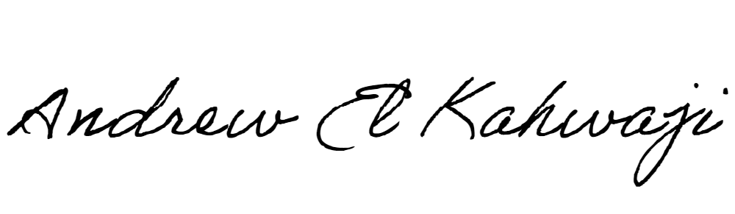

Printed Name _Andrew El Kahwaji_

Date __26/12/2024___

Email __andrew.lifesculptor.coo@gmail.com __

Phone __+961 71 914 378__